corporate authorization demo

1. Application 1 : Requestor Screen

* Table

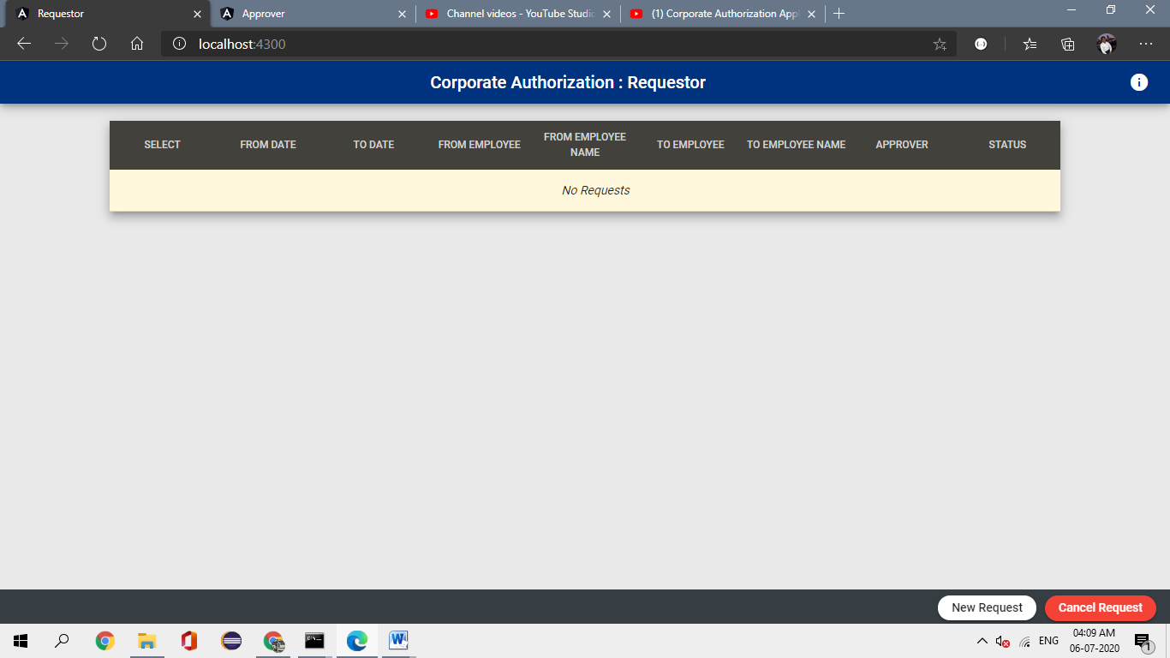

* New Request Form

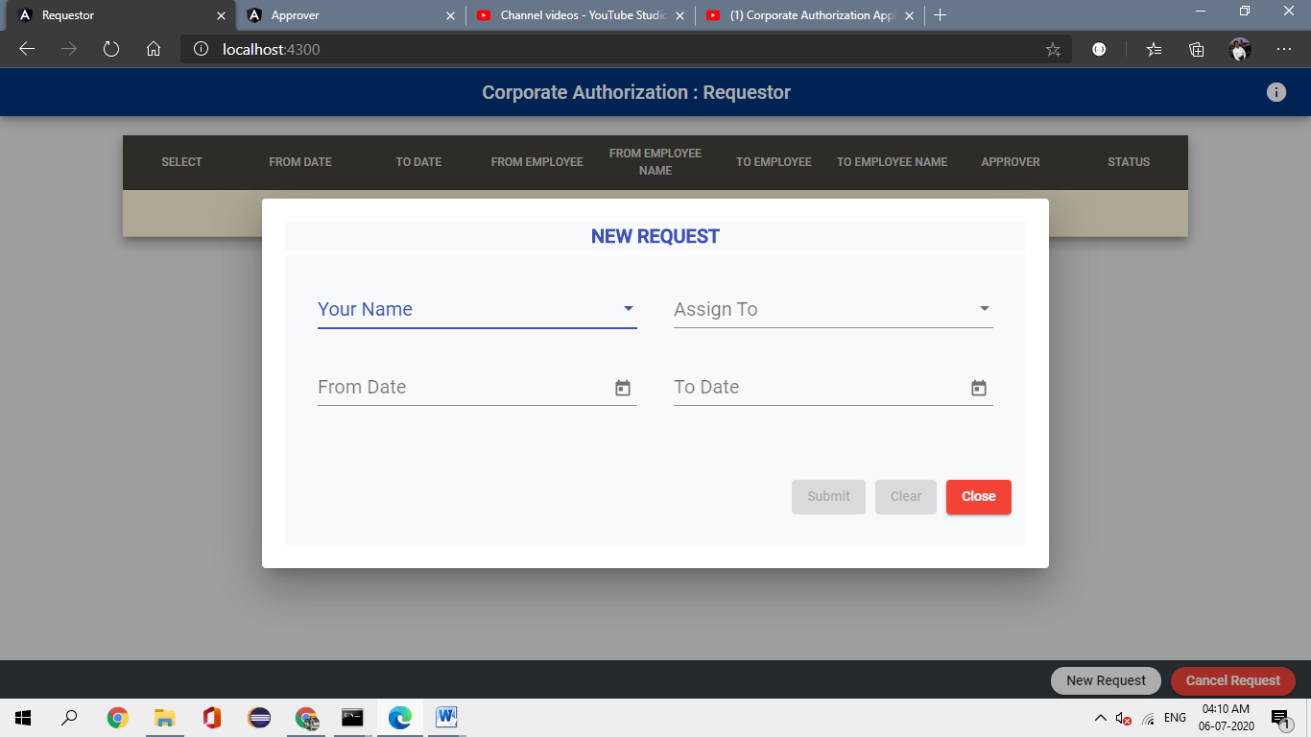

* Dropdowns (Selected Employee is removed from the second dropdown list

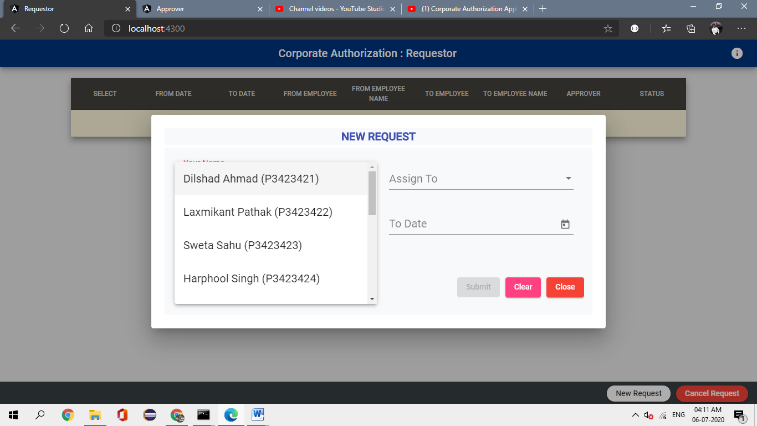

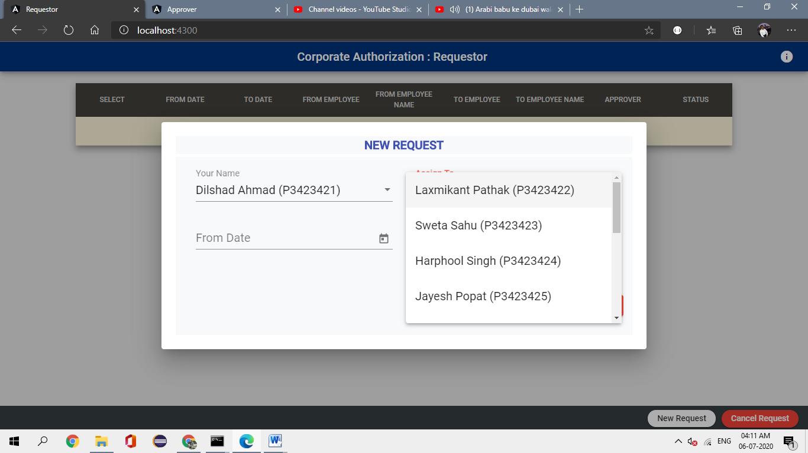

* After Submitting the form (status will be shown in different colour based upon its value)

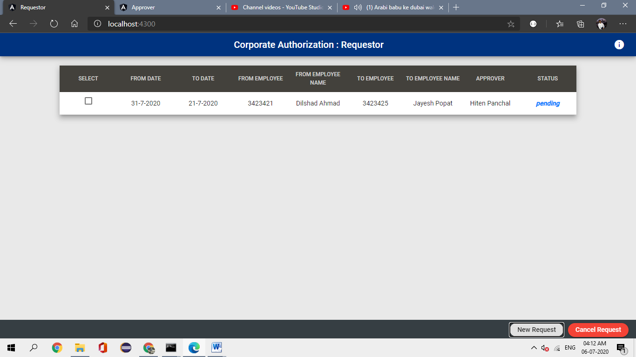

* Cancel Request Screen (button disabled until cancel selected)

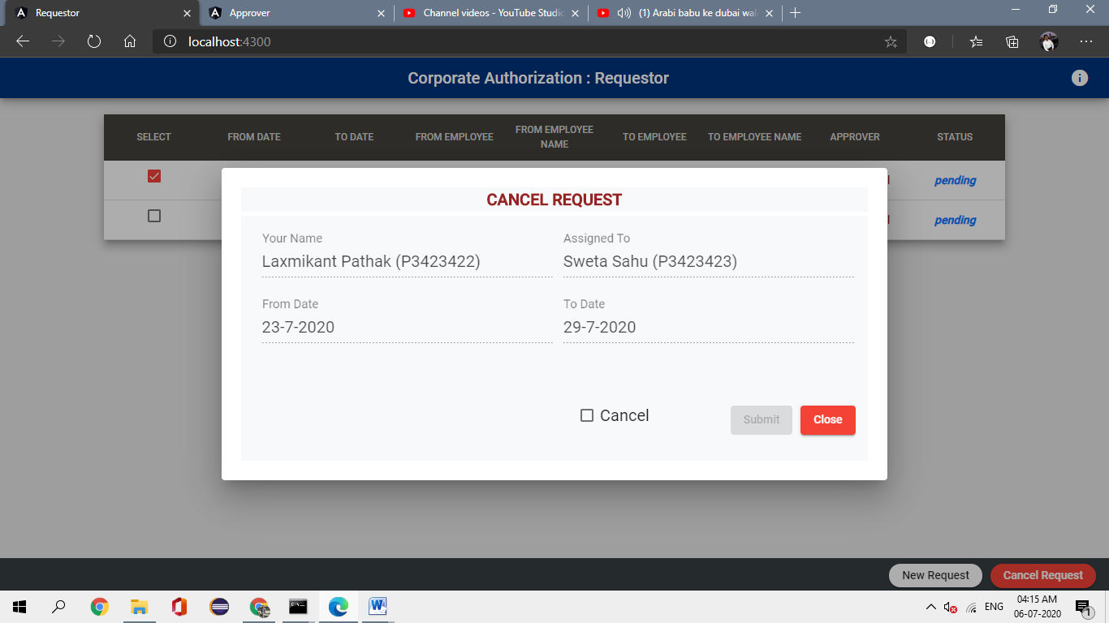

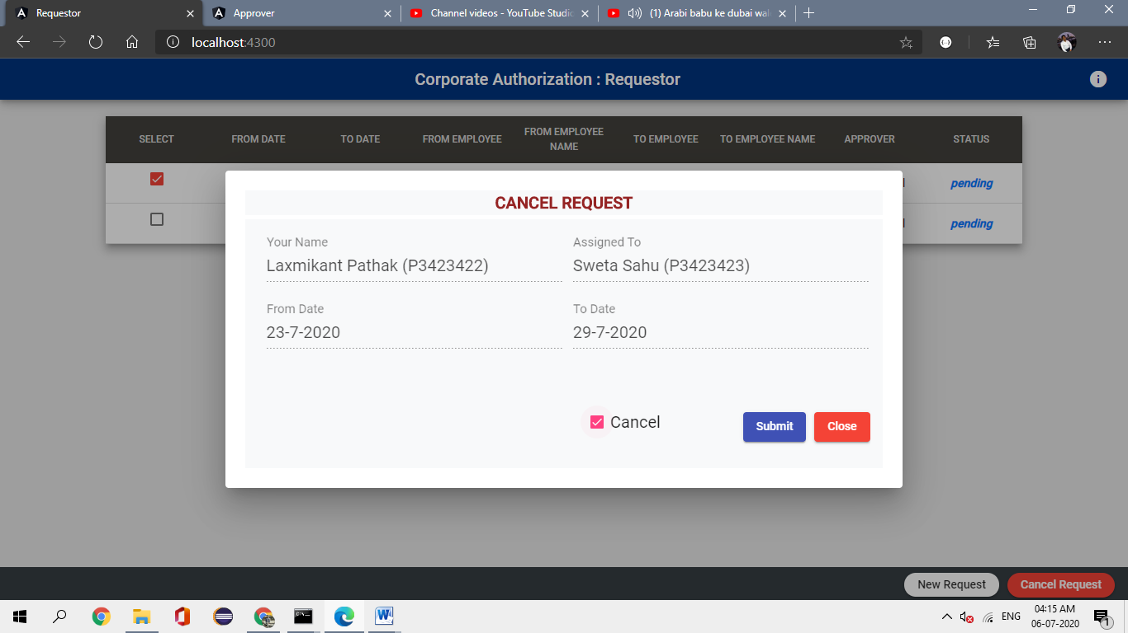

* After deleting all the requests (notification is shown in different colors)

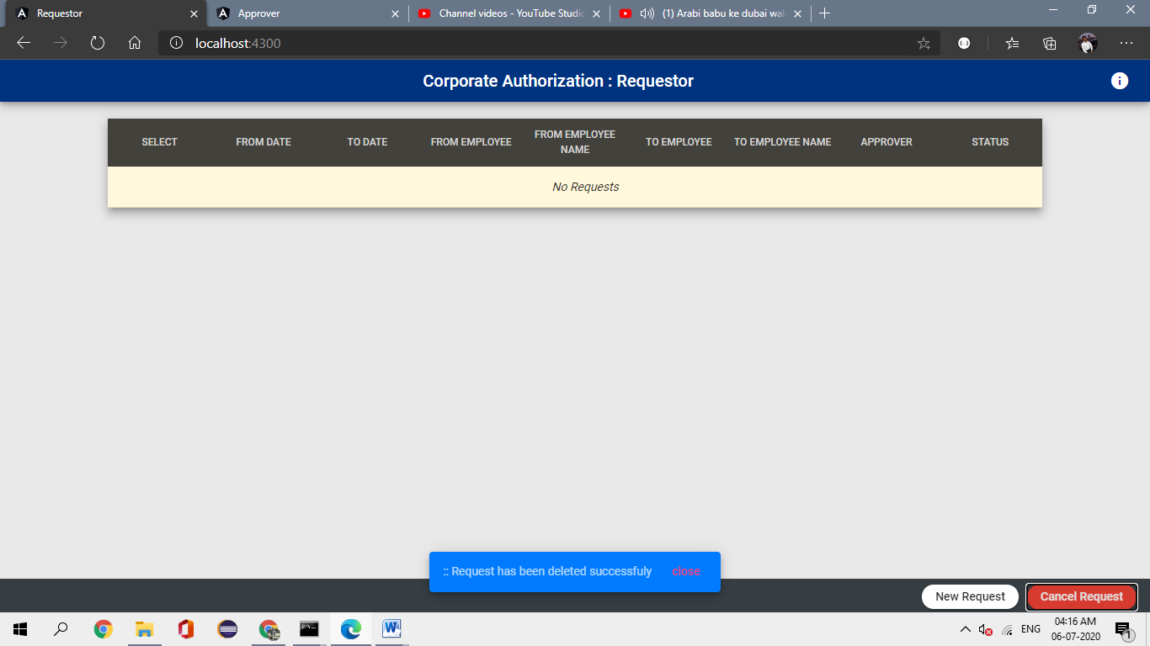

1. Application 2: Approver Screen

* Initial Screen

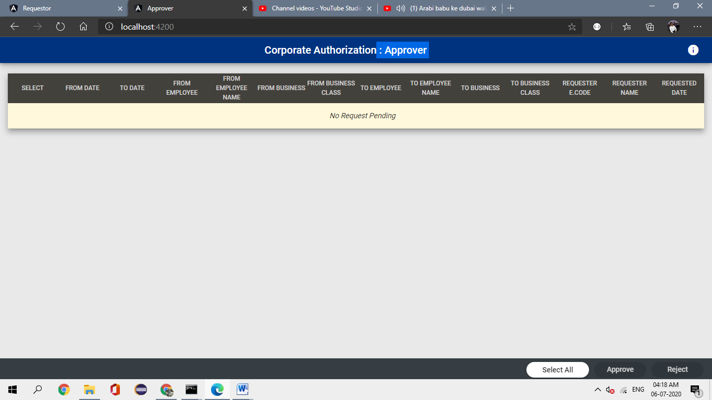

* Showing pending requests

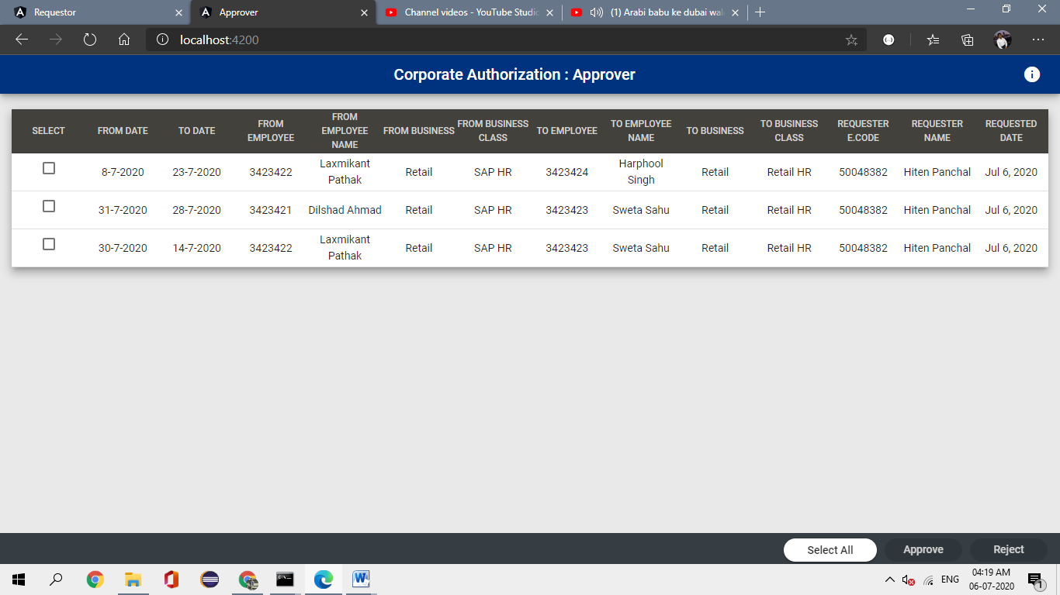

* Selecting unselecting all the values

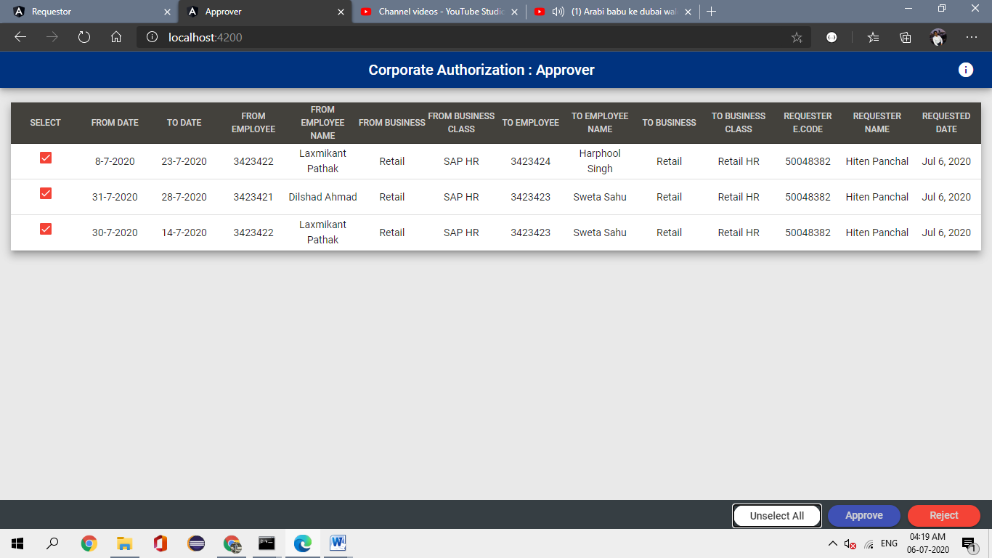

* Approve/ Reject Confirmations

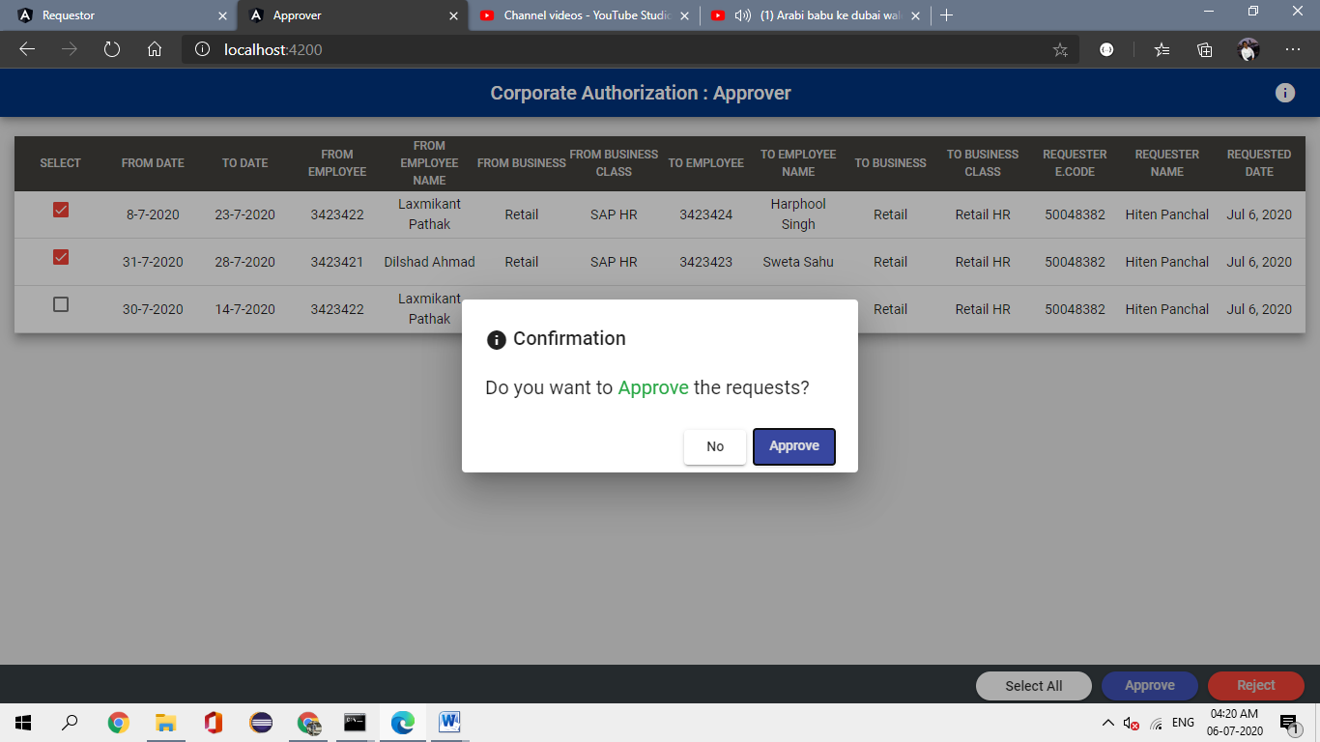

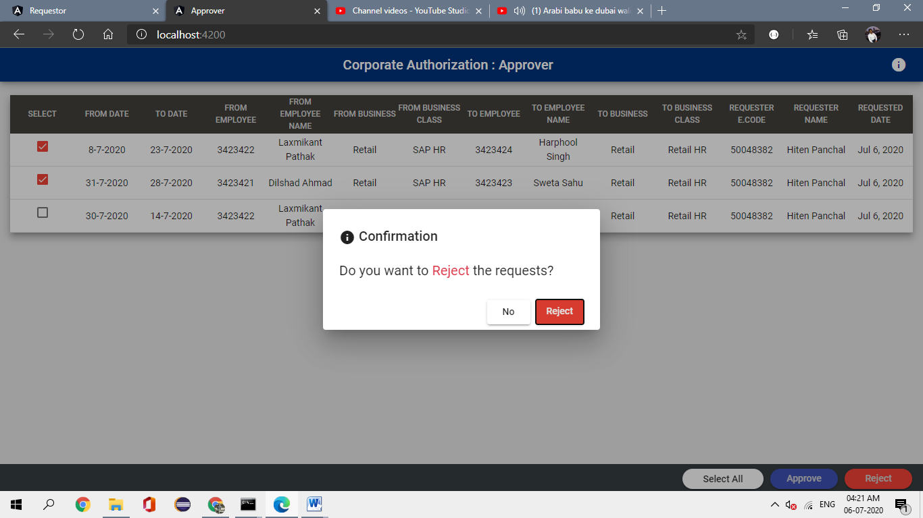

* Application 1 screen after approving or rejecting the requests

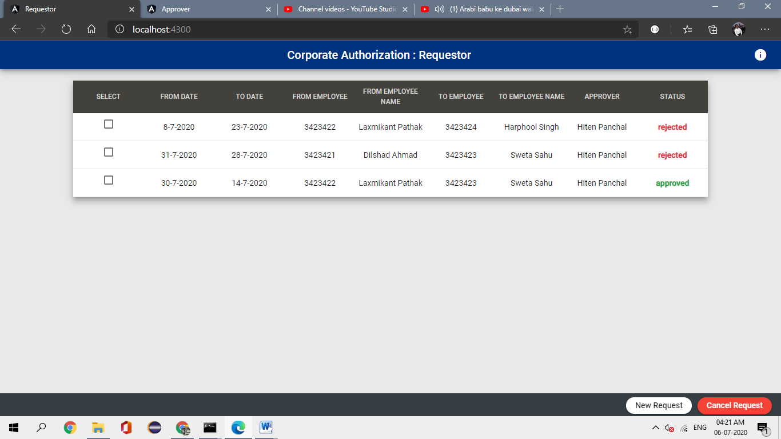

Thanks & Regards: DIlshad Ahmad